**JOB PORTAL**

**Introduction :-**

* This job portal basically concerned with different job services provided by different companies.
* It is also concerned with details of jobseekers.
* Jobseeker can view the list of different jobs and can apply for jobs.
* Then jobseeker can apply go through the required qualification.
* The portal going to follow different companies policy.

**Software Requirements :-**

#### Java : Jdk-18, Spring Tool Suite

* + - Database : MongoDB
    - Server : Web Server, Postman
    - Testing : Junit5

### 

### **Hardware Requirements :-**

* + - Processor : Core i3 and Above
    - RAM : 4GB
    - Hard disk capacity : 25 GB
* **Diagram:-**

**1)Activity Diagram:**

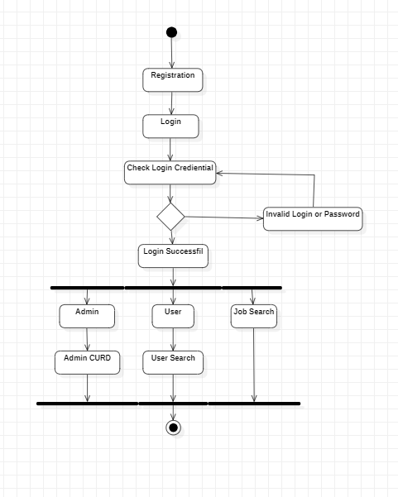

**2)Control Flow Diagram:**

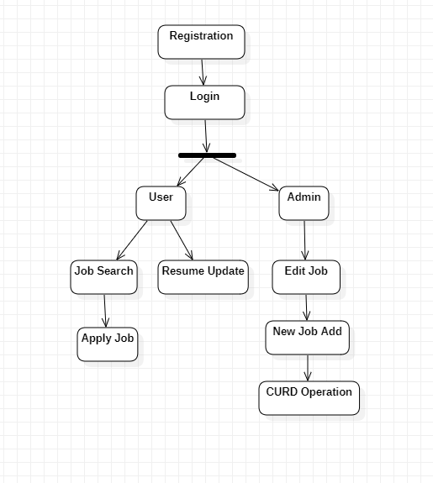

**3)Use Case Diagram:**

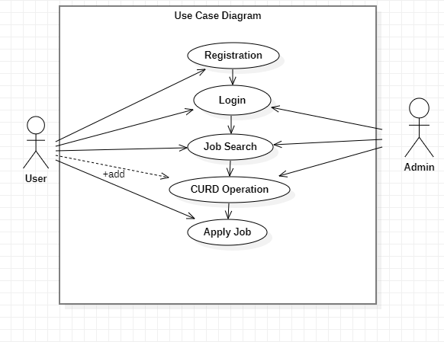

**User Story:-**

* **Modules:**
* Registration/Login
* **User Module**: User can search the job and add resume.
* **Admin Module**: Admin will add the job.
* **CURD Operation**: The admin can perform CURD operation in job details.
* **Search**: Admin and User can search the job and location
* **Characteristics:**
* The “User” is expected to be internet familiar and to be able to use the job portal.
* The “Admin” is expected to be familiar with internet and database.

**Admin:**

* Login
* Job Search
* Perform CURD Operation in Job
* Required Skill

**User:**

* Registration
* Login
* Job Search
* Add Resume
* Apply Job

**UI Screen Shots(Wire Frame) :-**

* **Services:-**
* Registration and Login Services
* User can Search the Job
* Admin will add the job
* User will perform curd operation in profile
* Admin Search by Requirement skill
* **Microservices:-**
* Eureka Service
* API Gateway
* Login Gateway
* **Code Coverage:**
  1. **Job_Portal_Admin:**

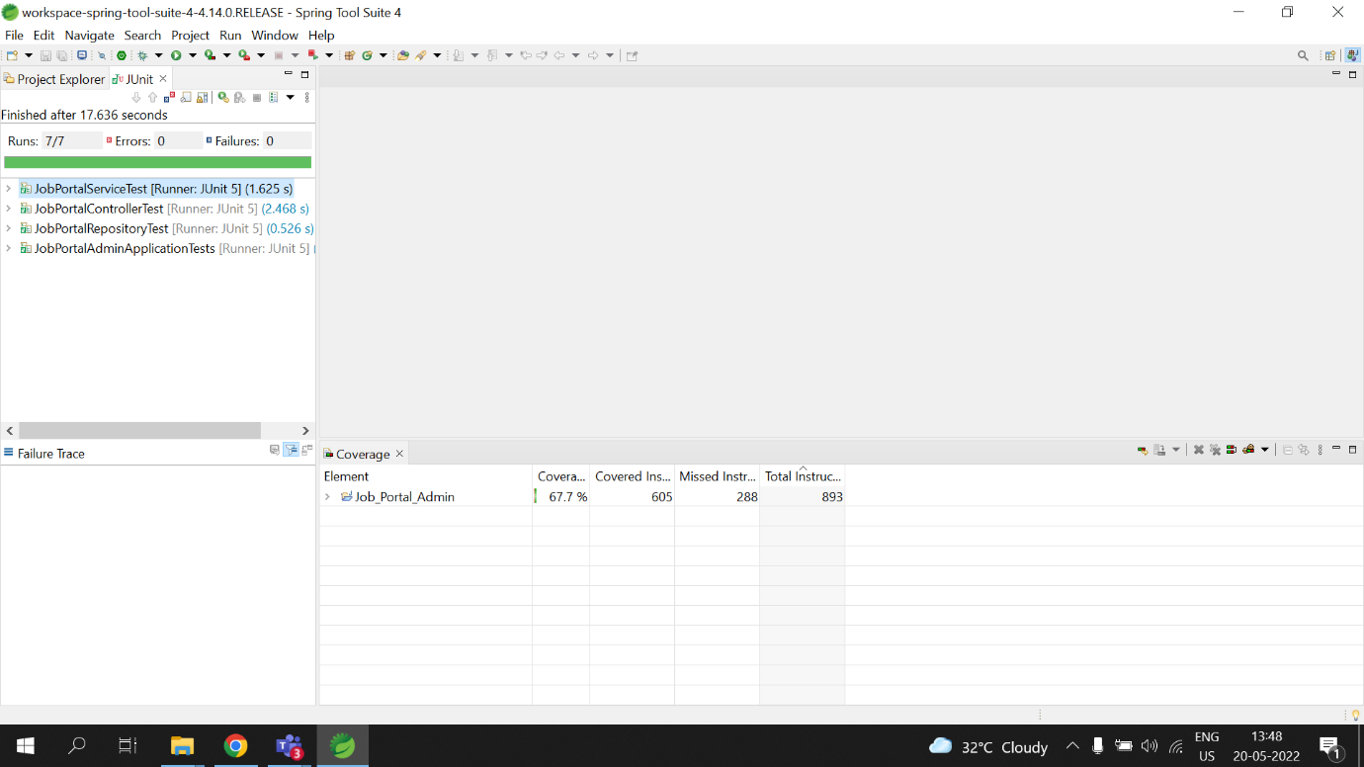

* 1. **Job_Portal_User:**

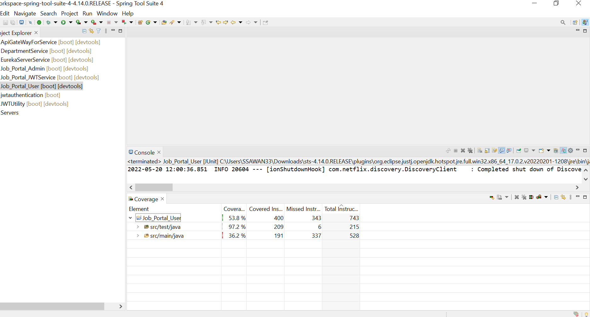

* 1. **Eureka Server Service:**

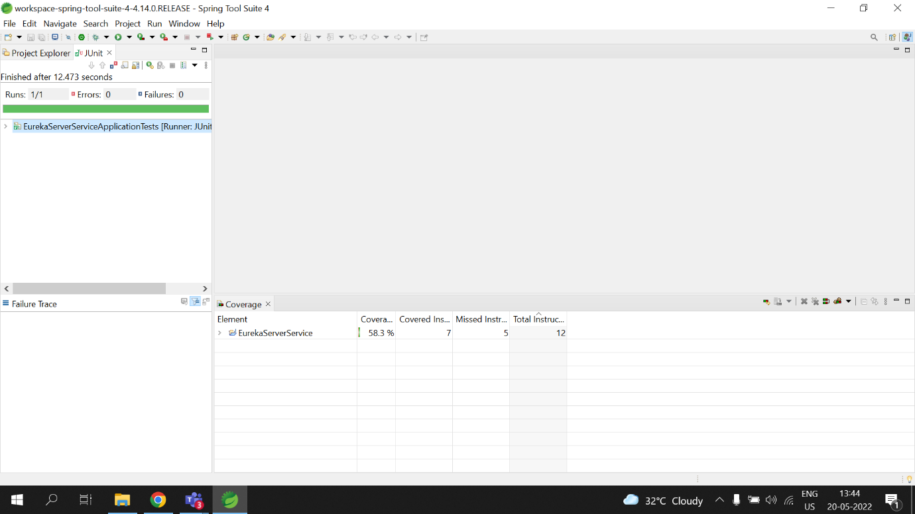

* 1. **API Gate Way For Service:**

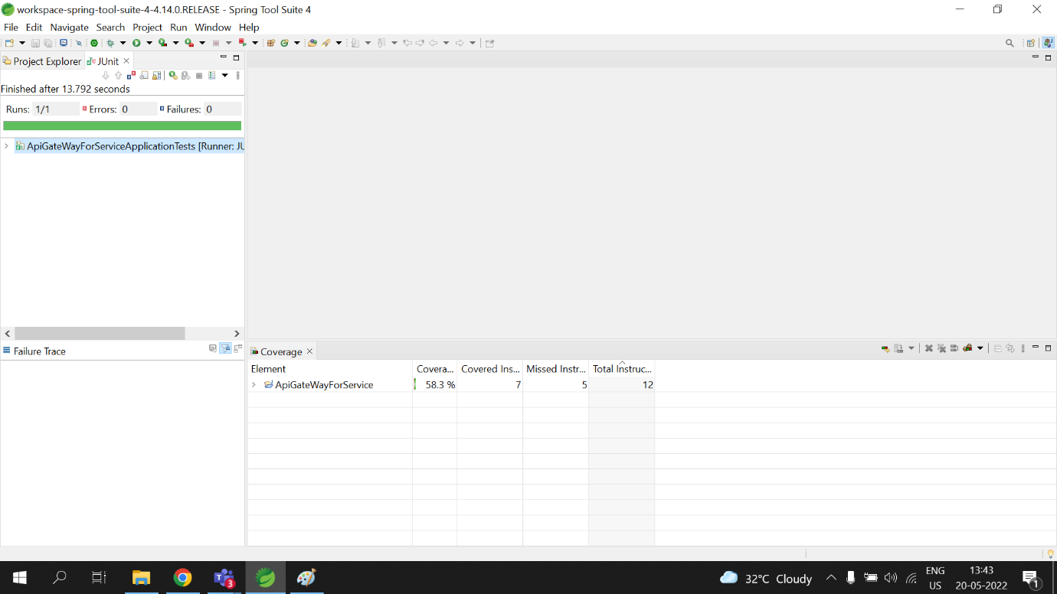

**1.5Job_Portal_Jwt_Service:**

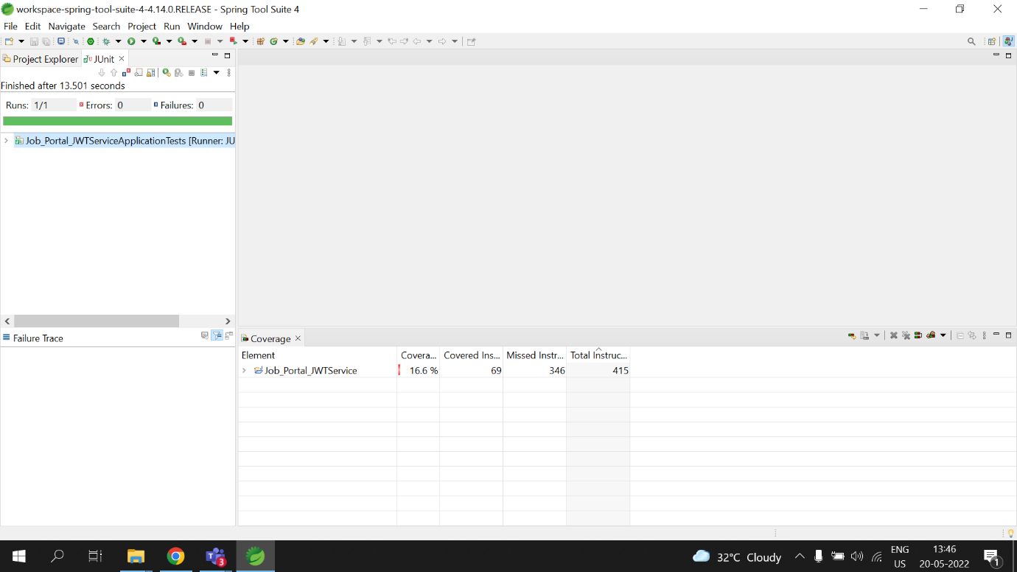

**Futher Enhancements :-**

* This web application involves almost all the features of the online service.
* The future implementation will be online help for the users and chatting with website administrators.
* There is ample scope of enhancement and adding functionalities to this application.
* This application can be extended to send automated interview scheduling through acceptance/rejection of Resume.
* Companies can delete jobs once the job availably period is over automatically.
* The portal can also send email notifications to candidates about certain job availabilities.
* There can be a feedback or review section for the application. Also unlike the current job description page, user can view job description in a separate page with one click on the job description.
* The User functionality can be extended to give the user options to save the job and later apply, to upload multiple documents.
* The application can be more scalable by extending the search functionality based on country, city or area. While this application meets the basic requirements of a job portal eliminating few of the traditional challenges faced like time, money and effort, it can be extended to make the application more dynamic and robust.
* The User Interface can be made more attractive and user friendly.

##### **Conclusion:**

* The wider areas of job searching facilitate the quick and easy access to opportunities.
* The increasing job opportunities and changing scenario of the business environment today has made more people to search for better career and employers to search for better potential.
* This situation has prompted many to move to job portals to look for the ways that has been widely accepted and fully useful in job searching.
* In this sense the job portals assumes greater importance and we could develop such an efficient system which is used by lot many job hunters and employers.
* At present times a bigger problem is unemployment. Many graduate freshers and employee can not find their jobs easily. By developing online job portal website I want to help them.